Circuit Analysis (Lab5)

Experiment 5: Introduction to Proteus

Name: Noor-ul-Ain

Date: 25 April , 2026.

Registration No: 2025-CE-83

Grade and Signature: …………………….

Construction Procedure
- The software Proteus Design Suite was opened on the computer system.
- A new project was created by selecting “New Design” from the File menu and choosing the default template.
- The component library was accessed by clicking on the ‘P’ (Pick Device) option.
- Required components were searched and selected from the library, including:
  - Resistors (R1, R2, R3)
  - DC Voltage Source (VDC)
  - Ground (GND)
  - Virtual instruments (DC Voltmeter and Ammeter)
- The selected components were placed onto the schematic workspace by clicking on the editing window.
- The components were arranged properly and connected using the wire tool to form a series circuit:
  - For Task 1: Voltage source connected in series with R1 and R2, followed by ground.
  - For Task 2: Voltage source connected in series with R1, R2, and R3, followed by ground.
- The ground terminal was connected to complete the circuit and ensure proper simulation.
- Measurement instruments were added:
  - Ammeter was connected in series to measure current.
  - Voltmeter was connected in parallel across resistors to measure voltage.
- The circuit connections were checked carefully to avoid errors such as loose wiring or incorrect placement of instruments.
- The simulation was started by clicking the Run (Play) button.
- Readings of current and voltage were observed from the instruments and recorded in the results table.
- The procedure was repeated for both circuits (Task 1 and Task 2) to obtain all required values.
TASK 1
R1 Voltage | R2 Voltage | Current
1.96 | 1.96 | 0.60

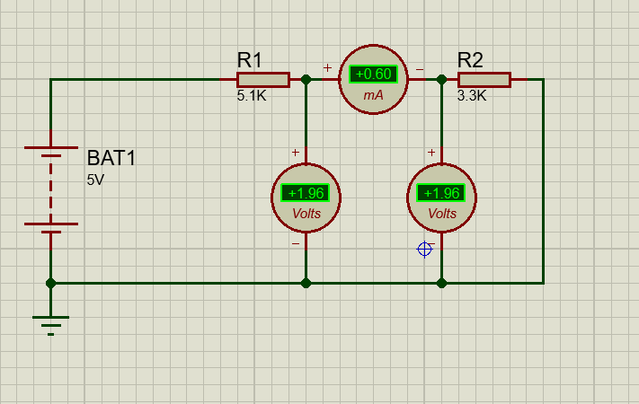

TASK 2
R1 Current | R2 Current | R3 Current | Voltage
0.84 | 0.28 | 0.56 | 0.56
